**Generic Sports Seller ltd**



Our system will sell sport equipment.

This program will provide a service selling sporting equipment to the general public. There will be a front-end system providing them with the ability to browse an array of stock and filter to specifically find equipment for their desired sport. There will be a generic shopping cart option which will allow the users to add the items they want to buy into it and create an order. To complete an order the user will be required to create an account which will store their personal information (such as name, address, age etc.) and their payment information.

As well as this front end which will be all the customer views, we will also create a staff facing back end. When a customer creates an order then said order will be added to a list of orders, ready to be processed. The backend will have various admin functions allowing us to properly manage the site, such as accessing or changing staff data, order information, customer data, and allowing us run repots on data stored in the system.

**Aston P2414525** – Order line management system.

**Elliot P2416030** – Stock management system.

**Sam P2413938** – Customer management system.

**Greg P2500674** – Staff management system.

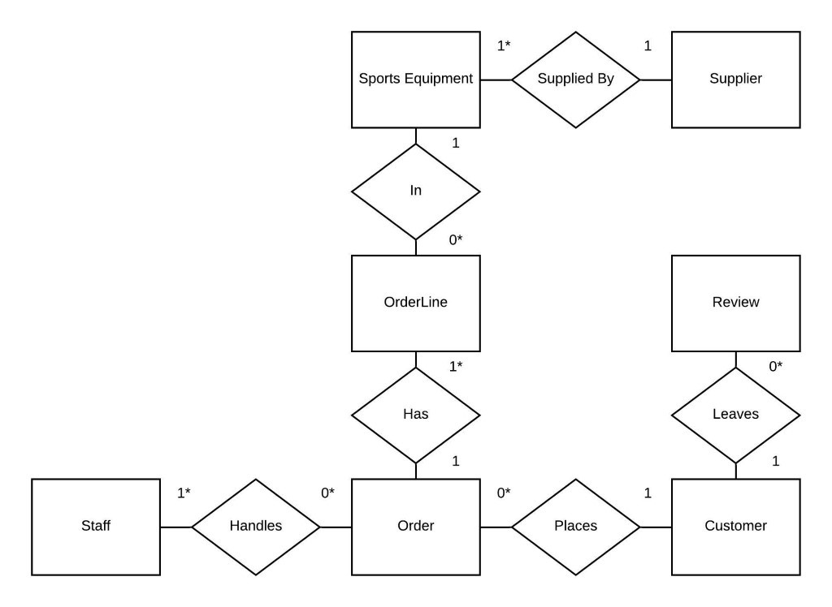

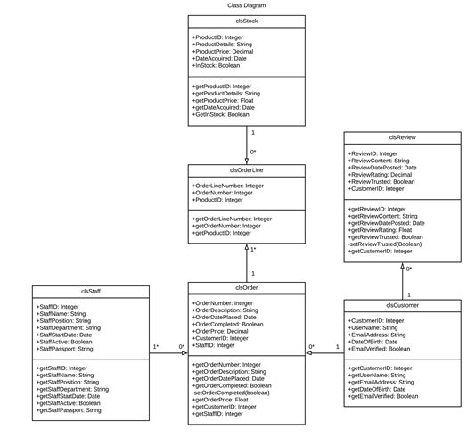

**Allocated Component:** Staff Management System

**Developer:**  Grzegorz Fordon P2500674

**Overview:**

This system is an application, developed to maintain the details of employees working for Generic Sports Seller ltd. It allows to record the current number of staff members according to department or position. The application also helps to create statistics based on the held details and provides search facility in order to find employees. When a new staff member is hired, their personal data is added to the system by administrator. After logging in, user depending on their position can perform specified operations:

Seller – can view their details only.

Manager – has rights to list and filter information about every employee working on the department.

Admin – has rights to add, edit, delete. filter and view every record in the database.

Every input data will be validated. Each person has an unique ID number, full name, password, hire date, current position, department and boolean value which indicates whether the person is currently working for the company.

|  |  |
| --- | --- |
| tblStaff | |
| staff_id | Integer – Primary Key |
| password | String |
| Full_name | String |
| hire_date | Date |
| position | String |
| department | String |
| is_active | Boolean |